Figure 4.

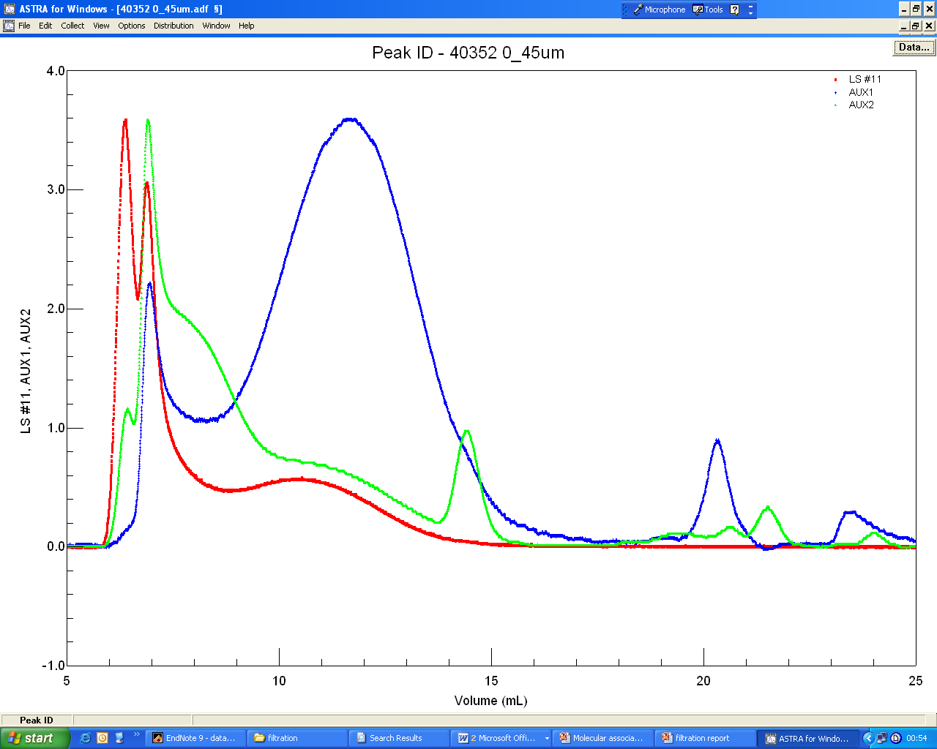
RI

UV

LS

