Figure 5.
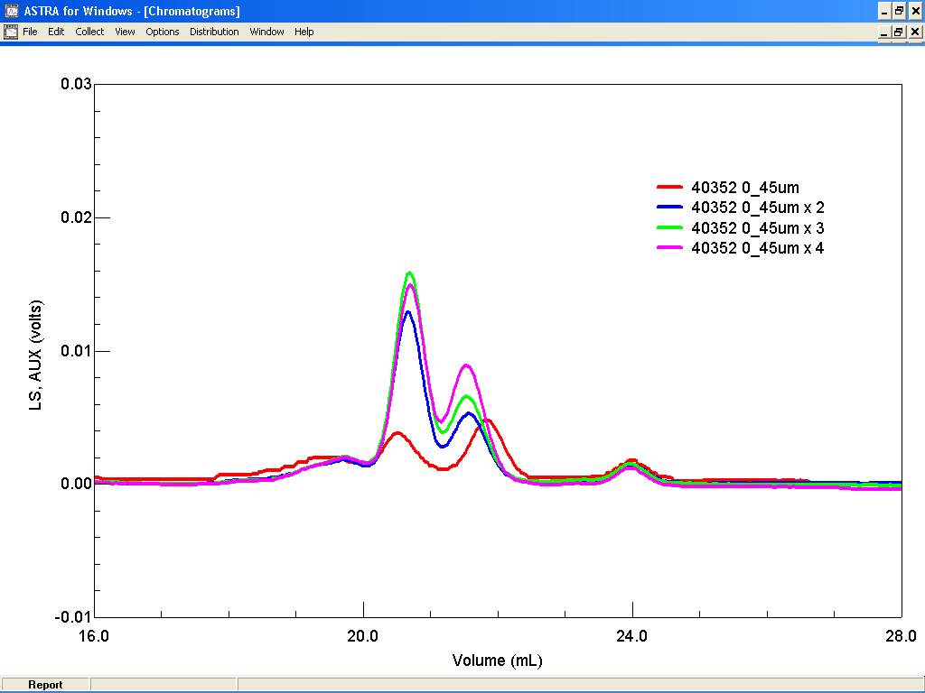
Peak height
x4
x3
x2
x1

