Supplementary information for
Magnetophoretic Assembly and Printing of Nanowires
Andrew C Wright* and Michael Faulkner
*To whom correspondence should be addressed a.wright@glyndwr.ac.uk

Horizontally aligned nickel nanorods Nickel nanorods can be directly printed from the magnetic head onto partly cured silicone rubber as shown in Figure 1. Some disturbance to the printed nanorods occurs due to lateral movement during the manual printing process where no precision jig has been used to prevent this.
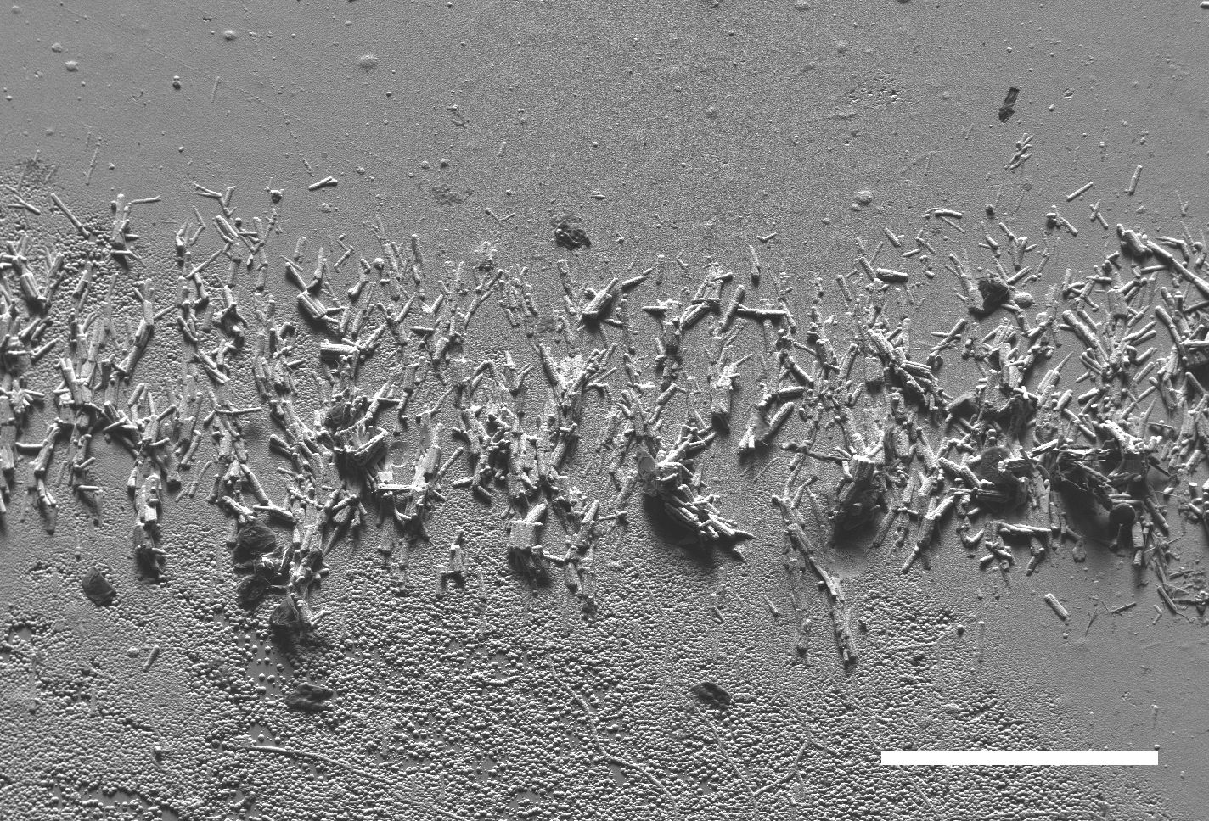
Figure 1: Horizontally aligned nickel nanorods printed onto partly cured silicone rubber pad. These were printed directly from the edge of a thin nickel foil magnetized with a single Alnico magnet. Material has been coated with Cr/Cu to avoid charging in SEM. Scale bar is 200 microns.

Fixing with UV-cured monomer in acetone Using either a double Alnico magnet arrangement or a stronger NdFeB magnet we find that vertical alignment can be achieved (Figure 2) in UV-cured adhesive/acetone mixture. Here, the ratio of adhesive to acetone was increased (4 drops adhesive to 4ml of acetone) to give a thicker film for embedding. Here, imaging with backscatter electrons rather than secondary electrons has been used to reveal the embedded nanorods.

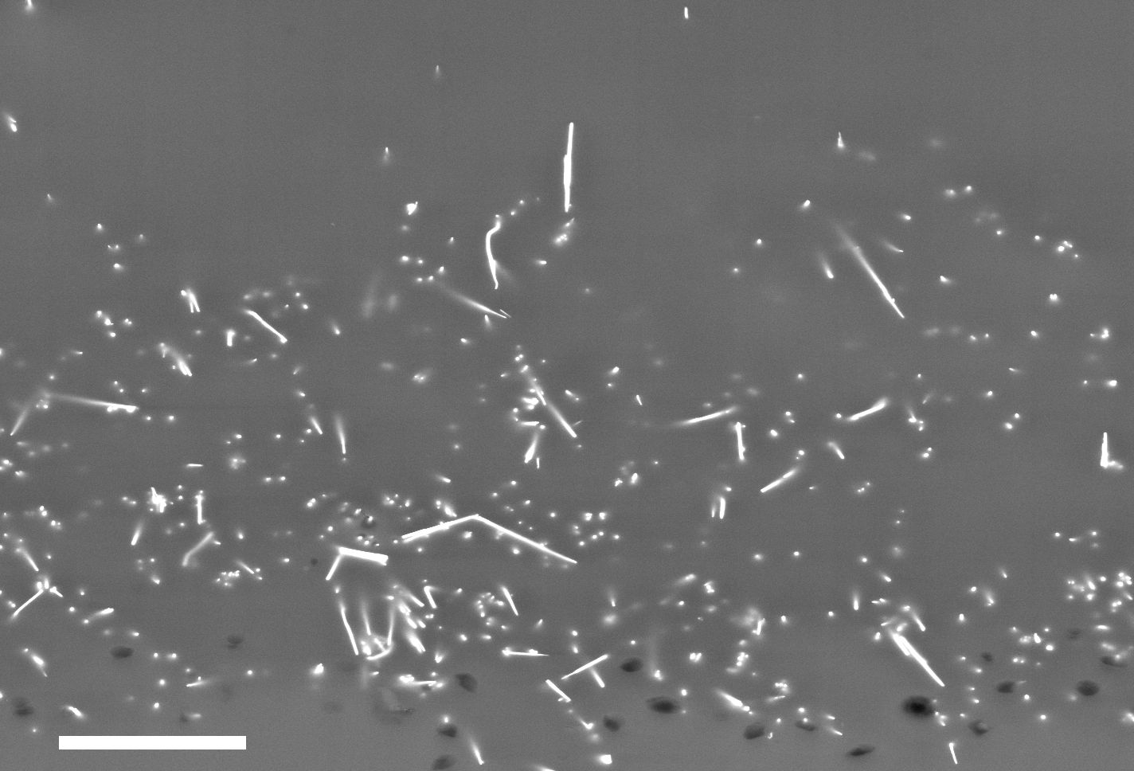
Figure 2: Vertically aligned nickel nanorods directly embedded in UV-cured polymer. Vertical alignment was achieved by use of a strong NdFeB magnet before curing (SEM BSE image, plan view). Scale bar is 20 microns.

Fixing with nickel electrodeposition in a vertical alignment We used Chromium (100nm) as a non magnetic electrically conductive underlay on polyimide and polyester substrates as it has good adhesion. However, electrodeposited nickel does not bond well to this and the resistance is somewhat higher than ideal.
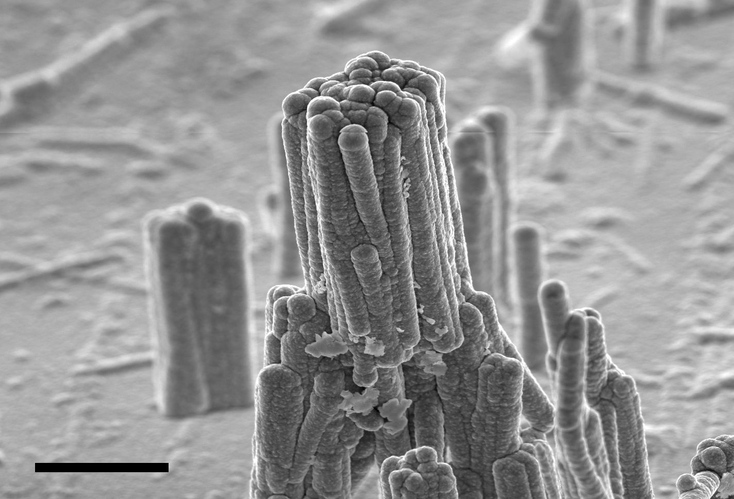
Figure 3: Vertically aligned nickel nanorods fixed in place with electrodeposited overcoat of nickel. End stacking of nickel nanofibers can be seen after formation from a dispersion in IPA solvent. Sideways bundling is caused by lack of separation after release from alumina template. Electroplating has increased apparent nanorod diameter to 2 microns. Scale bar is 20 microns.

Modeling of flux density at foil edge Computed flux density map, Figure 4, around edge of 50 micron nickel foil in single Alnico V magnet assembly. Note concentration of flux at foil corners. The blue rectangular area marks the boundary of a higher resolution mesh for calculations and the four points indicate the ends of the two levels at which transverse plots of flux density are produced, Figure 5.

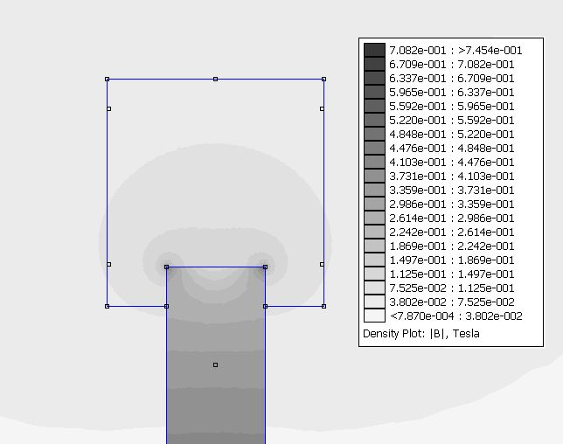
Figure 4: Flux density map across edge of nickel foil (bottom) showing concentration at foil corners. The four marks on the vertical edges of the box indicate where the flux profiles of Figure 5 are taken from with the upper two marks being 80 microns from the foil edge.

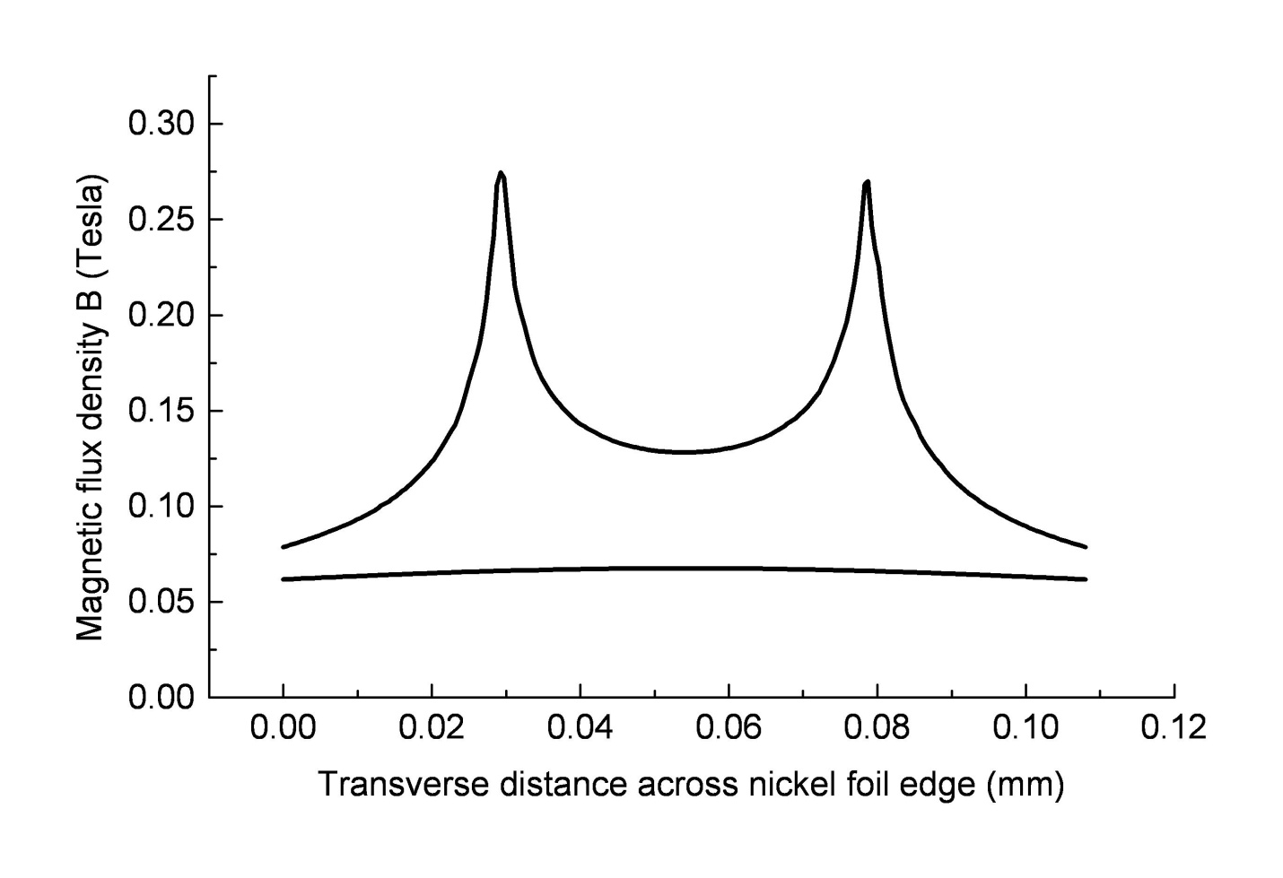
Figure 5: Computed profile of magnetic flux density across edge of nickel foil at two levels above foil edge. Strong peaks in magnetic flux are seen at the corners of foil (upper trace) while the lower trace shows almost flat flux profile when taken some 80 microns away from edge (in plane of substrate) showing how flux is now slightly greater in center.

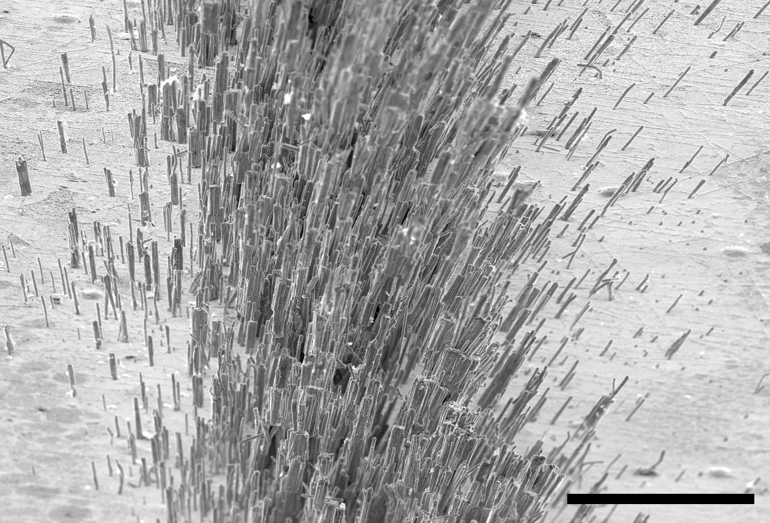
Figure 6: Diverging nature of magnetic field lines shown by orientation of nickel nanorods created with a strong (NdFeB) single magnet assembly. Center of ‘V’ is on left. View is along one arm of the ‘V’ shape as shown in Figure 2 in main article. Scale bar is 100 microns.

Materials and Methods Magnetic head creation Figure 7(a) shows thin nickel foil (50 microns, Goodfellow Metals Ltd.) bent into a ‘V’ shape and embedded in epoxy resin encapsulated in a fused silica tube. Figure 7(b) shows head mounted on magnetic grade (430) stainless steel disc (diameter 10mm, thickness 5mm) with Crystalbond wax with single Alnico magnet attached. Figure 7(c) shows polyimide foil (80 microns thick) with Cr sputter metallization (100nm) bonded with rubber cement to magnetic head. Here, the patterned Ni nanorods can be seen immediately after 10 second dip in ultrasonic dispersion of nanorods in IPA. The attraction of the nanorods was done with ultrasonication turned off.

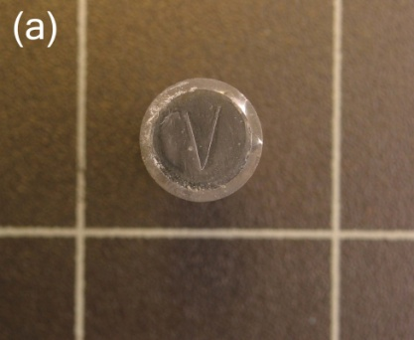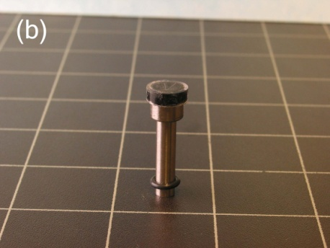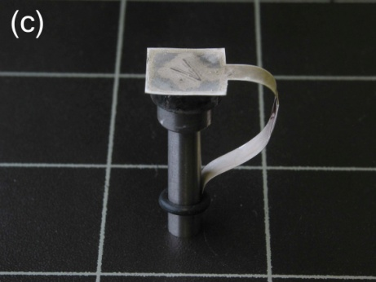
Figure 7: Magnetic assembly used in this paper. (a) ‘V’ shaped foil of nickel embedded in resin and glass tube and (b) mounted on soft magnetic disc with Alnico magnet. Rubber ‘O’ring around magnet is to hold strip of Kapton foil in place for electrical contacting as shown in (c) after magnetophoresis and galvanobonding steps.

Calculation of minimum force to attract a single nickel nanorod The downward force of gravity minus the upward force of buouyancy in IPA solvent (density 781 Kg/m³)can be readily calculated from the nanorod dimension and its density (8910 Kg/m³) as 4.5e⁻¹⁴N. We calculate the force to balance this from
$F=\frac{∂B}{∂x}\text{.}μ$ the product of the flux gradient and the magnetic moment of the nanorod. The latter is calulated from the mass of the nanorod (5.04e⁻¹⁵ Kg) giving from Avogadro’s constant 1.78e¹⁴ atoms. The magnetic moment is then simply a product of the number of atoms with the single electron magnetic moment (9.27e⁻²⁴ A/m²) and also with the experimentally known moment per nickel atom (0.54¹) giving 8.91e⁻¹⁰ A/m². The force to balance against gravity is then calculated to require a flux gradient of 0.0048 T/mm. Here we assume that all electron spins responsible for magnetism are fully aligned.

Field emission from vertically aligned nickel nanorods The ‘V’ structure shown in Figure 2(a) was mounted in field emission test jig, Figure8(a), consisting of a Macor ceramic spacer (500 microns thick, giving a minimum vacuum gap of around 450 microns) and a thin glass sheet coated with indium tin oxide (ITO, 10 Ohms per square) acting as the conductive anode which also performs the function of a phosphor. The jig was mounted in a small stainless steel chamber fitted with a turbo-molecular drag pump giving a base pressure after bake out of 1 x 10⁻⁸ mbar. The nickel nanorods emitter surface was created on thin flattened copper foil with nickel overplating and was driven negative relative to ground via an EG&G Ortec 556 high voltage power supply fed through two 1 MΩ resistors to limit the current. Field emission was observed at applied negative voltages beyond 2kV as discrete points of light along the ‘V’ as shown in Figure 8(b).

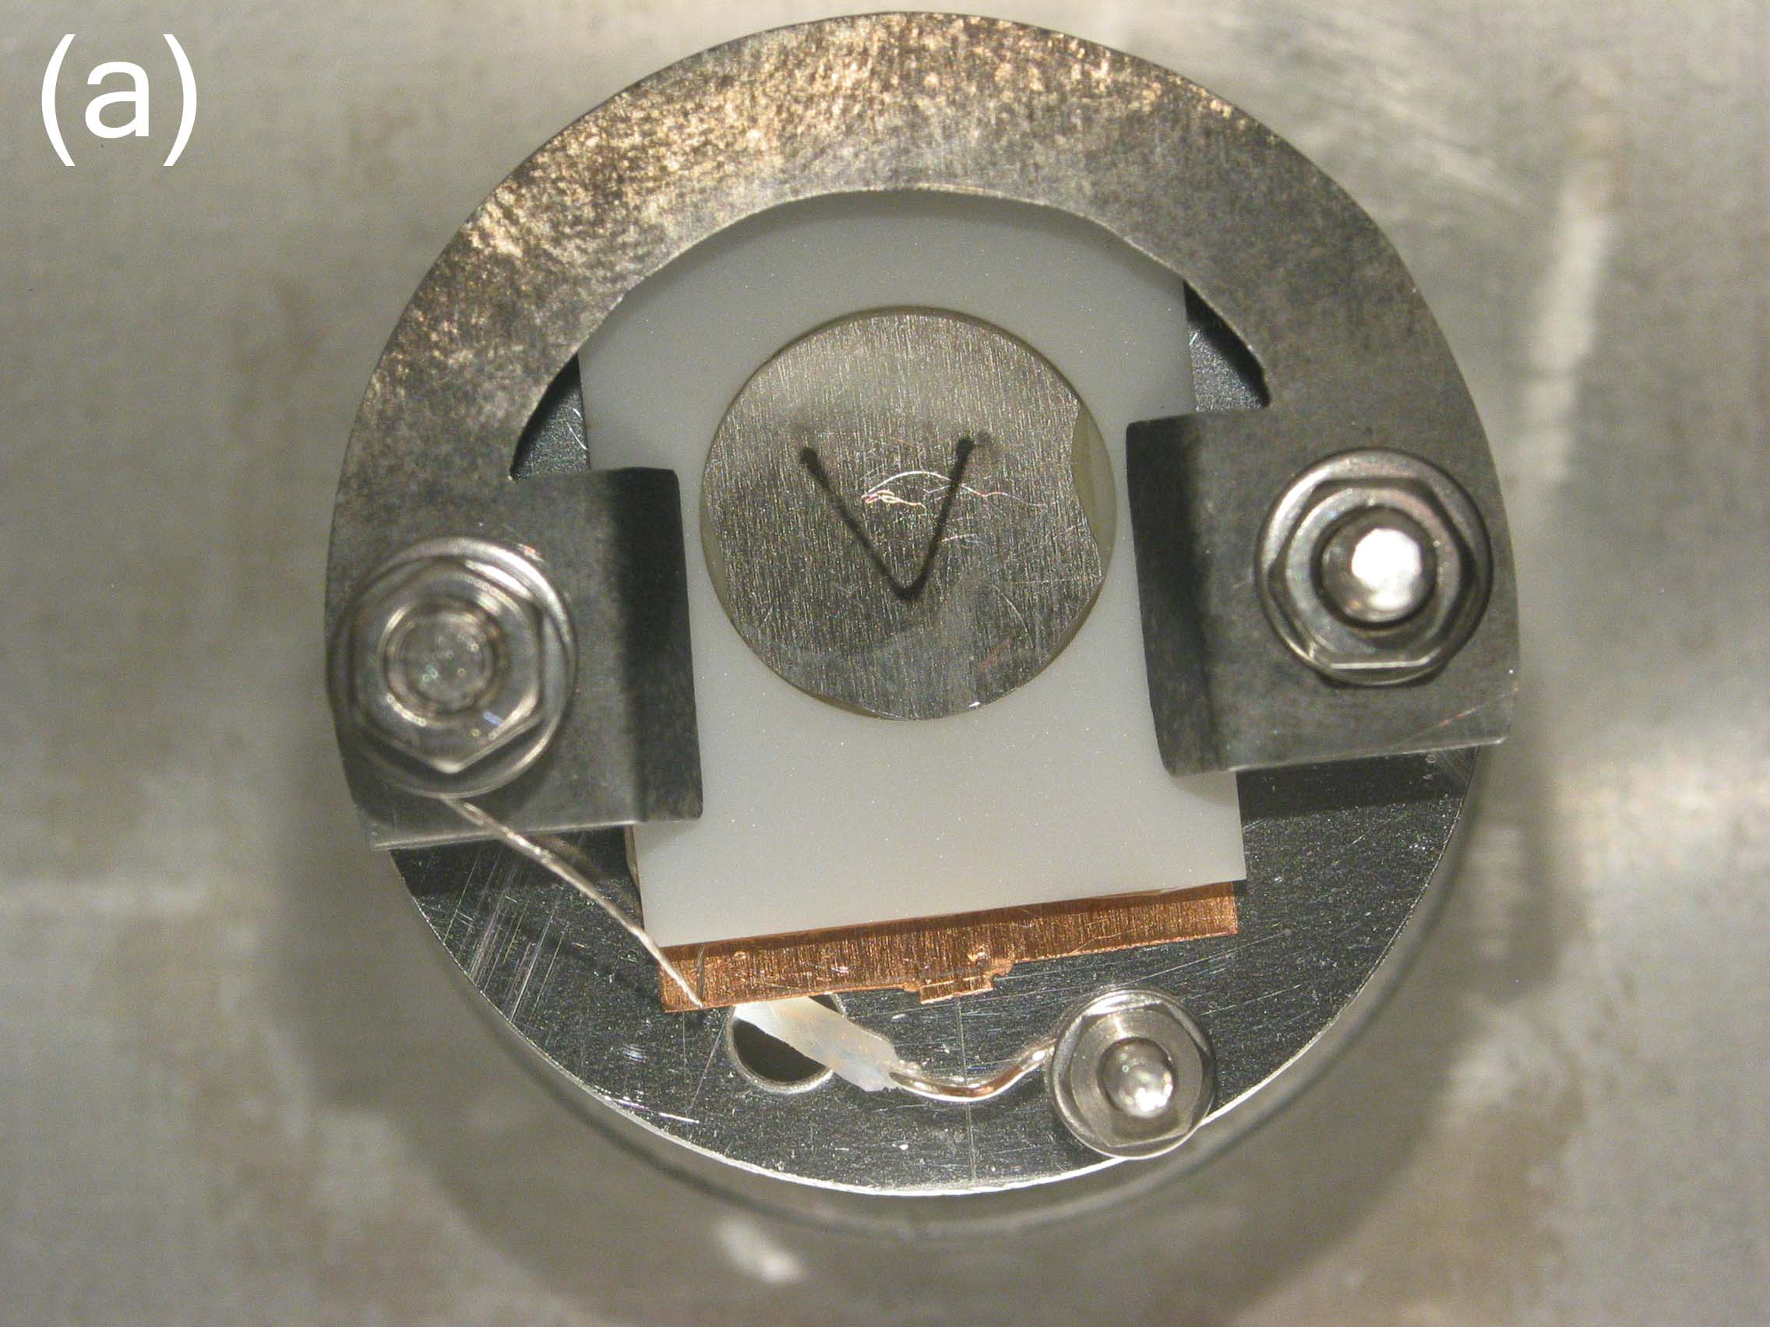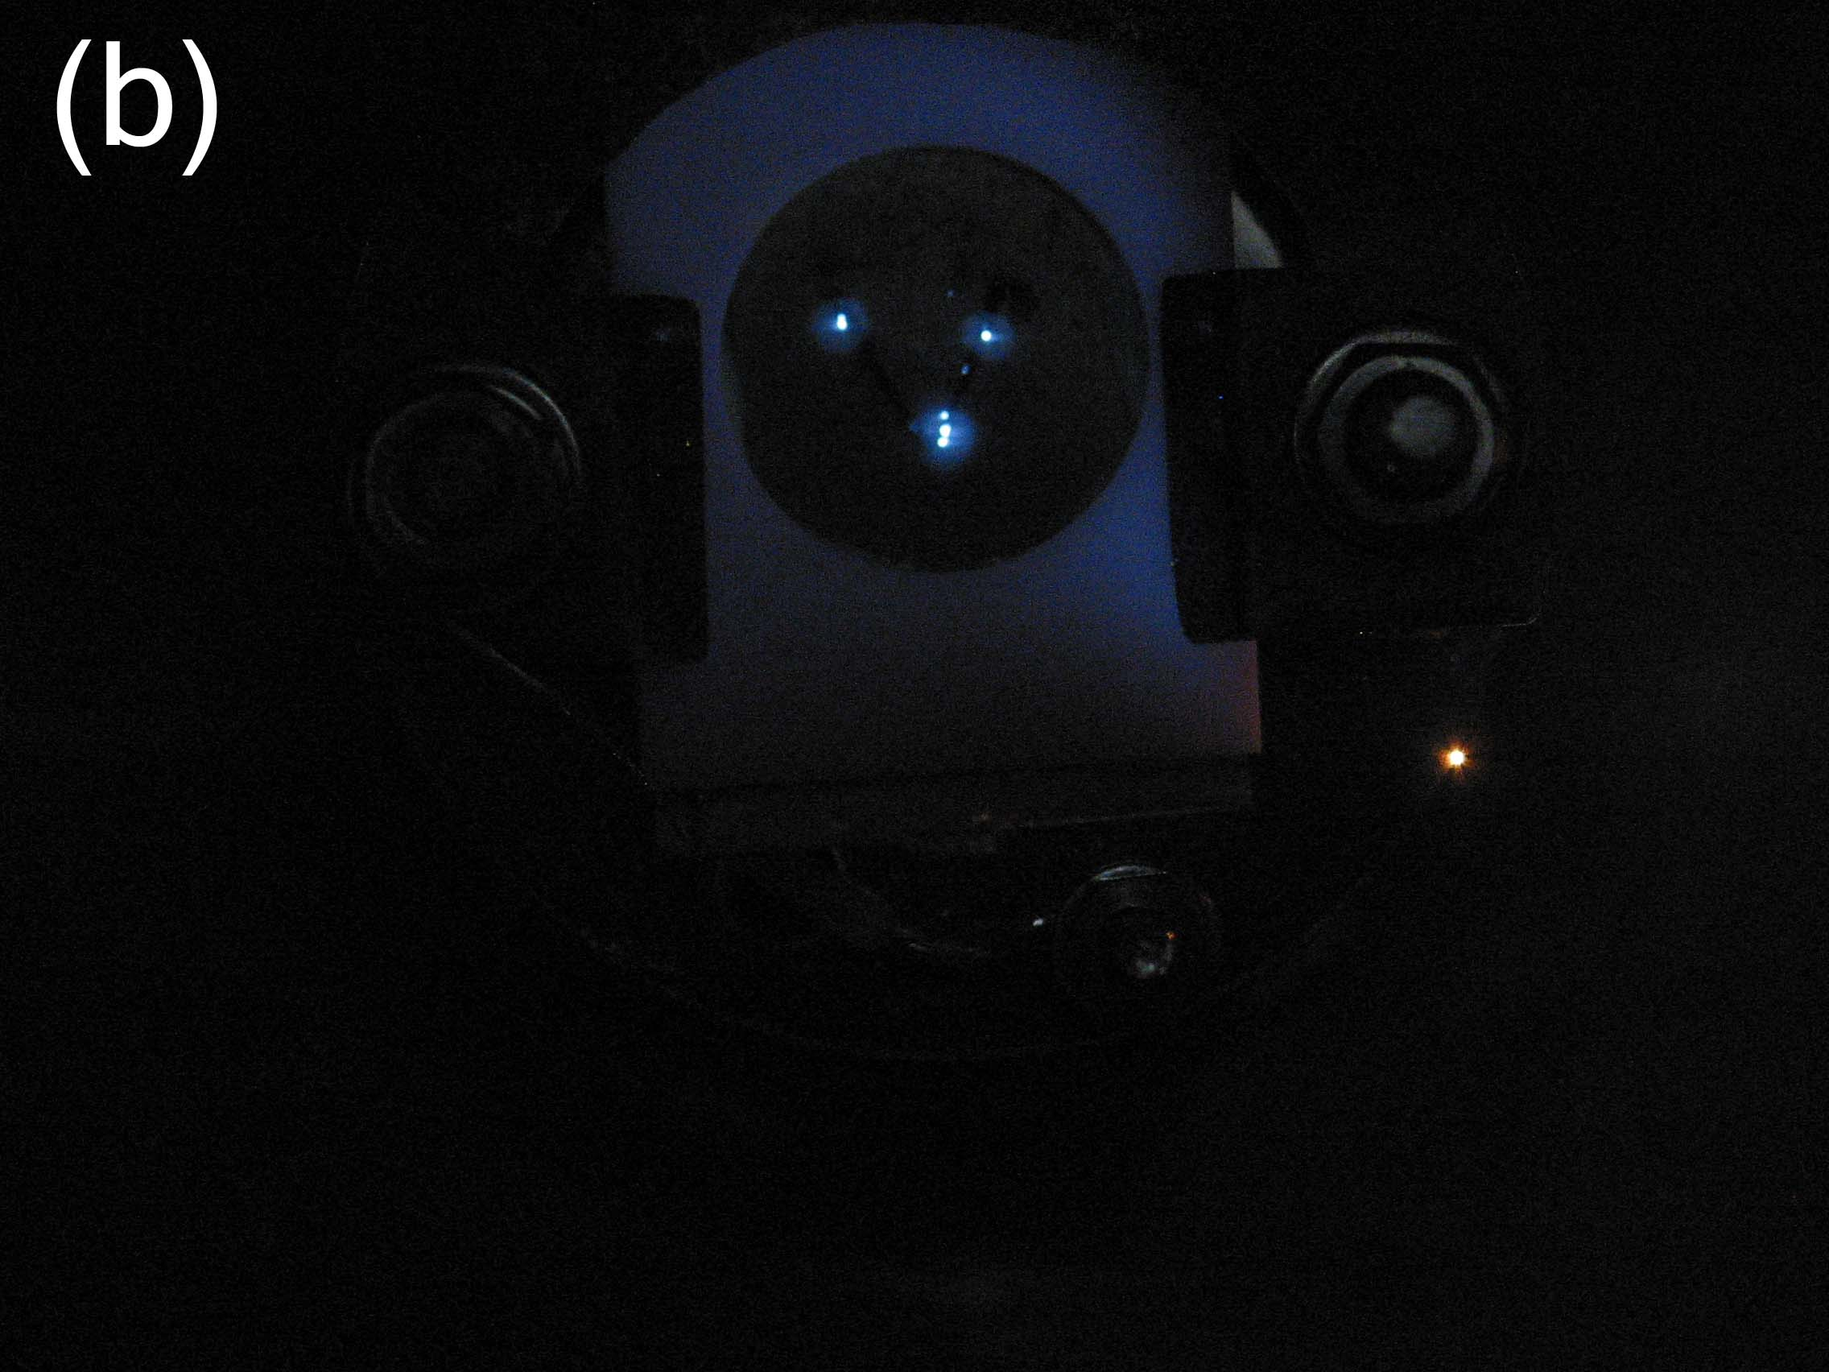
Figure 8: Field emission device built from vertically aligned nickel nanorods. (a) shows plan view of test rig while (b) shows discrete light emission from tallest nanorods at applied voltage of 2kV. Some light emission also comes from the Macor ceramic.

References
1. Kittel C. Introduction to Solid State Physics. (Wiley 1976)

