Some Insights on The Assessment of Enterprise Education in the Secondary Sector
[Figures and Tables]
Authors: Matthew C. Draycott, David Rae, Katie Vause
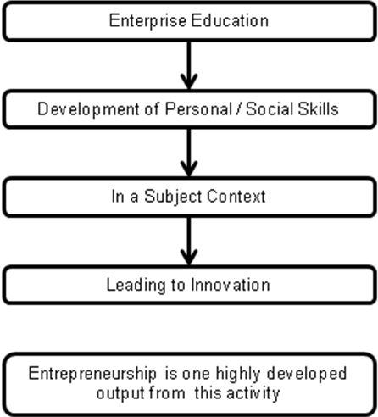

Fig.1 Enterprise Education in a subject context

Learning Outcome | Criteria
Innovative entrepreneur – developing the enterprise skill set of young learners through recognising, challenging and strengthening a host of entrepreneurial traits. | 1 Understand how entrepreneurs are creative  2 Be able to encourage creativity  3 Be able to assess proposals developed from new ideas  4 Be able to develop and assess own entrepreneurial skills and attributes.
Becoming a competent entrepreneur – developing the business knowledge and entrepreneurial understanding of how to present a case for a viable, financially sound and low risk idea. | 1 Be able to produce a coherent business plan document  2 Financial and budgetary control  3 Be able to pitch a viable business idea  4 Be able to assess the risk of business decisions in the context of the macro environment
Becoming an active entrepreneur – focus on the ability of learners to lead others and contribute in a team of individuals.  Example testable learning objectives include: | 1 Understand the importance of teams  2 Understand leadership attributes and skills  3 Be able to contribute effectively as a team member and leader  4 Be able to assess effectiveness of team performance.

Table 1: Enterprise Learning Outcomes Gathered from Secondary Educators

Approach | Type(s) of Assessment | Strengths | Weaknesses
Enterprise Passport | Self assessment  (assessment as learning) | This approach allows a range of skills to be monitored, improvements logged and learning traced to its source. It’s relatively simple and requires few resources to put in place. | The approach is wholly student centred and is without any form of progression criteria, it requires a lot of commitment from both staff and students to produce results that are useful for student progression, including training in the use of the passport.
Performance Radar | Self assessment  (assessment for learning) | The approach allows students to review their own work and judge it against a number of criteria to see how their skills are developing. It can include a wide range of data and store it online for easy access and review. | The tool has a high degree of perceived complexity and could require a lot of training of students to produce useful data, as they would need to understand all the various statements and what they mean.
Benchmarking of enterprise capability | Self assessment  (assessment for learning) | Simple self assessment against a wide range of capabilities that can be repeated to show progression against previous scores. | Large range of capabilities (25) has no traceability and does not develop high quality reflection as it is just a scoring exercise. Also there are potential issues of validity and reliability stemming from students different understanding of the benchmark statements.
Personal Effectiveness tool | Self assessment, peer assessment and tutor assessment  (assessment for, as and of learning) | A structured online assessment tool that helps students assess their development in relation to a wide range of activities, it includes the full range of assessment and highlights areas for development as well as providing a high degree of traceability. | This tool relies on a high degree of IT competency and staff time to both create activities and input assessments and requires a regular commitment to keep it up to date.
Award Scheme | Self assessment  (assessment as learning) | As simple self assessment supported by an awards scheme to promote the use of the tool it takes into account a wide range of data, provides traceability, and incentives students to interact with the system. | The tool needs a large degree of training to allow the students to generate meaningful results in terms if the assessment and it is unclear as to how, if at all the data will be reviewed by staff to shape learning.
In-lesson assessment of enterprise capabilities | Self assessment, peer assessment and tutor assessment  (assessment for, as and of learning) | A mixed assessment methodology centred on a series of competency statements that the students need to reply to, it presents the full range of assessment with excellent traceability and large quantities of high quality assessment from all sides. | The tool needs a lot of time from all individuals involved and uses a lot of paper making storage and review an issue.

Table 2: A Review of the Assessment Approaches in the 2008 NFER Report
Layer 2
Financial literacy
Economic & business understanding
Personal Enterprise Skills
Enterprise Skills
Assessment for learning
Assessment as learning
Assessment of learning
Assessment
Social
Extra –
curricula
Intra – curricula
Context
Layer 3 (Potential Example of the Personal Enterprise Skills Element Only)

Self Awareness
Practical Creativity
Action Orientation
Strategic Thinking
Opportunity Awareness
Collaborative Working
Layer 1
Fig. 2 Working Model of the ‘Stratified Enterprise Pedagogy’

Enterprise Skills
Context
Assessment

‘The Enterprise Space’

© Matthew C. Draycott, Katie Vause, David Rae 2010

Learner’s Progression, Over Time
Assessment
Enterprise Skills
Context
The Growth of the ‘Enterprise Space’ over Time
Assessment
Enterprise Skills
Context
Assessment
Enterprise Skills
Context
Assessment
Enterprise Skills
Context
Enterprise Space
Enterprise Space
Fig. 3 Working Model of the ‘Stratified Enterprise Pedagogy’ In Three Dimensions
© Matthew C. Draycott, Katie Vause, David Rae 2010
‘Enterprise Space’
Waypoint | Keywords
I am able to investigate the market demand for a business opportunity | Investigate  Review  Explore  Market  Marketplace  Town  Location  Demographics  Age  Demand  Want  Requirement  Need  Business  Company  Organisation  Enterprise  Opportunity  Prospect

Table 3: Example of a Waypoint and its Semantic Keywords

